**Software Design Description (SDD)**

Table of Contents

**1.** **Introduction** 2

**1.1** **Design overview** 2

**2.** **SYSTEM ARCHITECTURAL DESIGN** 3

**2.1** **Chosen system architectural** 3

**2.2** **Dicussion of alternative design** 3

**3.** **DETAILED DESCRIPTION OF COMPONENTS** 4

**3.1** **Quizzes** 4

**3.2** **User** 4

**3.3** **Multiple choices questions (MCQ)** 4

**3.4** **Choices** 4

**3.5** **History** 4

**4.** **User Interface design** 5

**4.1** **Main page** 5

**4.2** **Setting** 6

**4.3** **New Quizzes** 7

**4.4** **Your Quizzes** 8

**4.5** **Public Quizzes.** 9

**4.6** **Overview** 10

1. **Introduction**
   1. **Design overview**

The Quizzes is designed to be a convenient and easy to use tool for everyone.

Firstly, there will be a page for registration and logging in. After that, users will get into main page, there they can use all the funtion of The Quizzes.

There are 5 main functions:

* **Setting:** This function is used to manage and edit information about account, including password and avatar.
* **New Quizzes:** Here users can creat new quizzes by adding title, description, the questions, and their answers as well. They can also set the privacy of this quiz by choosing whether to publish or not.
* **Your Quizzes:** Here users can manage their own quizzes. They can edit title, description, privacy. They can also edit or delete the questions in each quiz. Besides, they can even do their own quizzes.
* **Public Quizzes:** This functions will show the users a list of all public quizzes accompany with the information of those quizzes, such as author, description, numbers of questions, number of likes. By selecting one of them, they will be led to one of 2 cases.
* If they select their own quiz: They can do the same with the functions “Your Quizzes” mentioned above.
* If they select other’s quize: They can only do this quiz.
* **Overview:** This functions is to show the progress of the users. It will store the times the users take a quiz and the result as well.

Besides, after doing a quiz, user can hit the like button if they like that quiz. This button not only for the user to express their feeling but also help the others decide quizzes to do.

1. **SYSTEM ARCHITECTURAL DESIGN** 
   1. **Chosen system architectural**

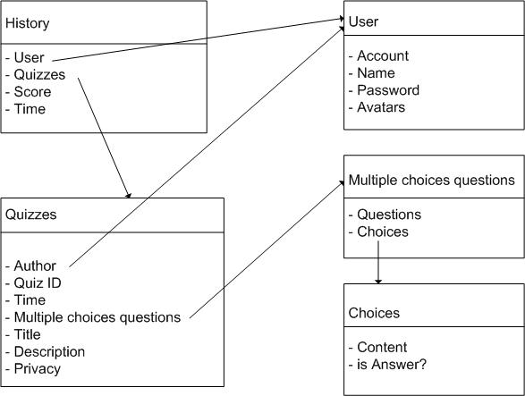

* 1. **Dicussion of alternative design**

We came to the consistency to use the above design at the begin. So that we don’t have any alternative design.

1. **DETAILED DESCRIPTION OF COMPONENTS**

There are 5 main components in the system: Quizzes, User, Multiple choices question, Choices and history. We will have a deeper look on each of above components.

* 1. **Quizzes**

Quizzes is a components in that the information of quizzes be stored. In a quiz, we will have the following data:

* The author: It will link to an element of Users, indicate that this user is the author of this quiz.
* Quizz ID: To manage quizzes effectively and easily, we assign to each quiz one ID, that each time we want to access a quiz, we will work with its ID.
* Time: Stores the time the quiz being created.
* Multiple choices questions: A quiz has many multiple choices questions (MCQ). MCQ is also another component. This field will link to the questions(an elements) in MCQ.
* Tilte, description, privacy: Stores the information about tile, desciption and privacy of that quiz.
  1. **User**

This component stores the users’s profile. Specifically:

* Acount: The acount of user.
* Name: The displayed name of user
* Password: Password of this account
  1. **Multiple choices questions (MCQ)**

This component store all the questions of all quiz. Each question will have a quiz link to it. Each MCQ contains:

* Question: The content of question
* Choices: Link to an element of another component: Choices.
  1. **Choices**

Similar to MCQ, this component store all the choices of all questions. Each choice will have a MCQ link to it. Each choice contains:

* Content: The content of this answer.
* IsAnswer: Indicate where this choice is the answer of the question linking to it.
  1. **History**

This component store all the time a user do a quiz. Each time we have to store:

* User: Link to user
* Quizzes: Link to quizzes
* Time and score: Store time and score of that time.

1. **User Interface design**

We tried to make the user interface as simple and convenient as possible. To be more specific, take a look at the images below:

* 1. **Main page**

At the main page, user can creat an account or log in if they have already had an account. After creating successfully, the user will go to log in site. Logging in, user can access 4 main functions: Setting, New Quizzes, Your quizzes, Public Quizzes and Overview.

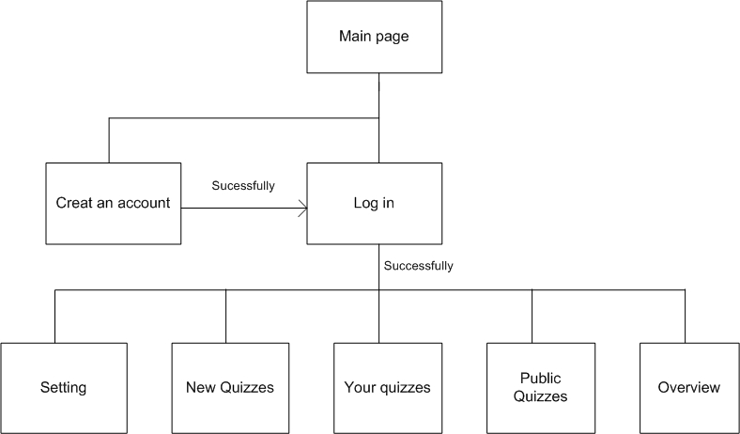

* 1. **Setting**

In setting functions: user can change password, change avatar or delete avatar. We allow user to have more than 1 avatar simultaneously. So each time you change avatar, you can choose an available avatar or upload new avatar. When you want to delete avatars, you can delete more than 1 as well.

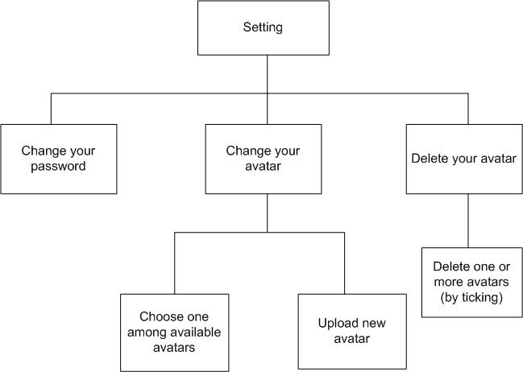

* 1. **New Quizzes**

After selecting this function, you will have to fill the title, desciption and privacy of this quiz. Then you can do some actions listed below.

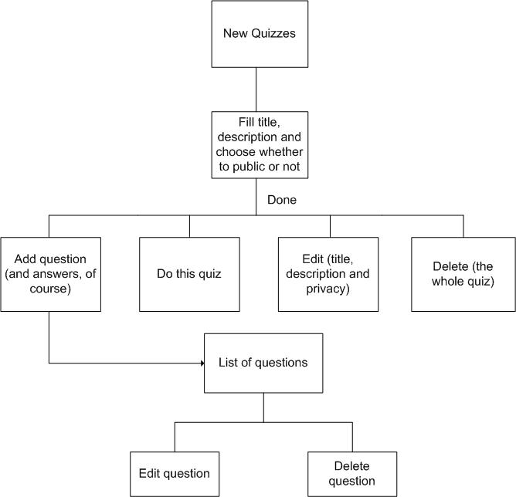

* 1. **Your Quizzes**

If you choose this function, you can manage and edit your own quizzes. It is not so different from New Quizzes.

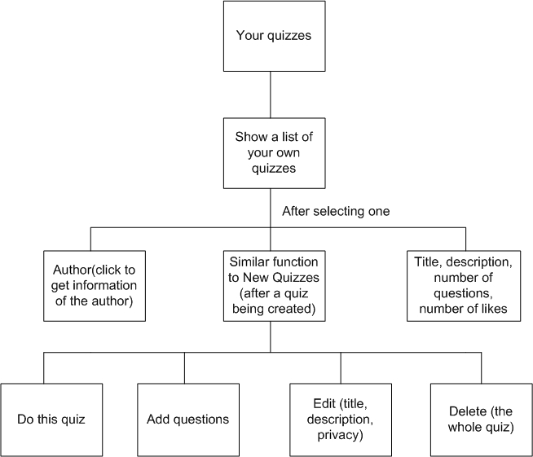

* 1. **Public Quizzes.**

This function allow you to do and see the information of all public quizzes.

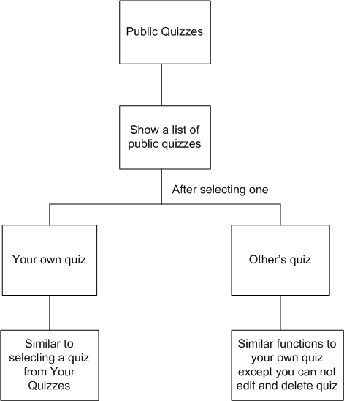

* 1. **Overview**